Phrasal Appositive

🔹 What is Phrasal Appositive?
# Source: AI Source: Provided by: [Data Path: Persons Table -> ID Column: 1, Name_En Column: Motasem Essam] -> From: [Chatgpt (GPT‑5 Mini)] on [8/7/2025]
A phrasal appositive is a group of words (a phrase)—usually a noun phrase—that renames or further identifies a noun in a sentence. Unlike single-word appositives, phrasal appositives contain more than one word.

🔸 Key Features:
# Source: AI Source: Provided by: [Data Path: Persons Table -> ID Column: 1, Name_En Column: Motasem Essam] -> From: [Chatgpt (GPT‑5 Mini)] on [8/7/2025]
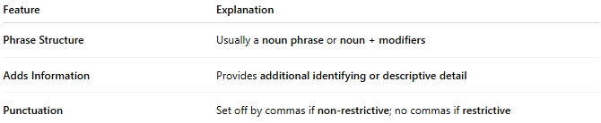
Feature | Explanation
Phrase Structure | Usually a noun phrase or noun + modifiers
Adds Information | Provides additional identifying or descriptive detail
Punctuation | Set off by commas if non-restrictive; no commas if restrictive

🔸 Examples:
# Source: AI Source: Provided by: [Data Path: Persons Table -> ID Column: 1, Name_En Column: Motasem Essam] -> From: [Chatgpt (GPT‑5 Mini)] on [8/7/2025]
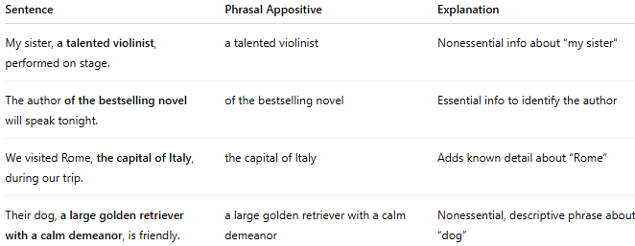
Sentence | Phrasal Appositive | Explanation
My sister, a talented violinist, performed on stage. | a talented violinist | Nonessential info about “my sister”
The author of the bestselling novel will speak tonight. | of the bestselling novel | Essential info to identify the author
We visited Rome, the capital of Italy, during our trip. | the capital of Italy | Adds known detail about “Rome”
Their dog, a large golden retriever with a calm demeanor, is friendly. | a large golden retriever with a calm demeanor | Nonessential, descriptive phrase about “dog”

